**Airbnb**

**User**

Create

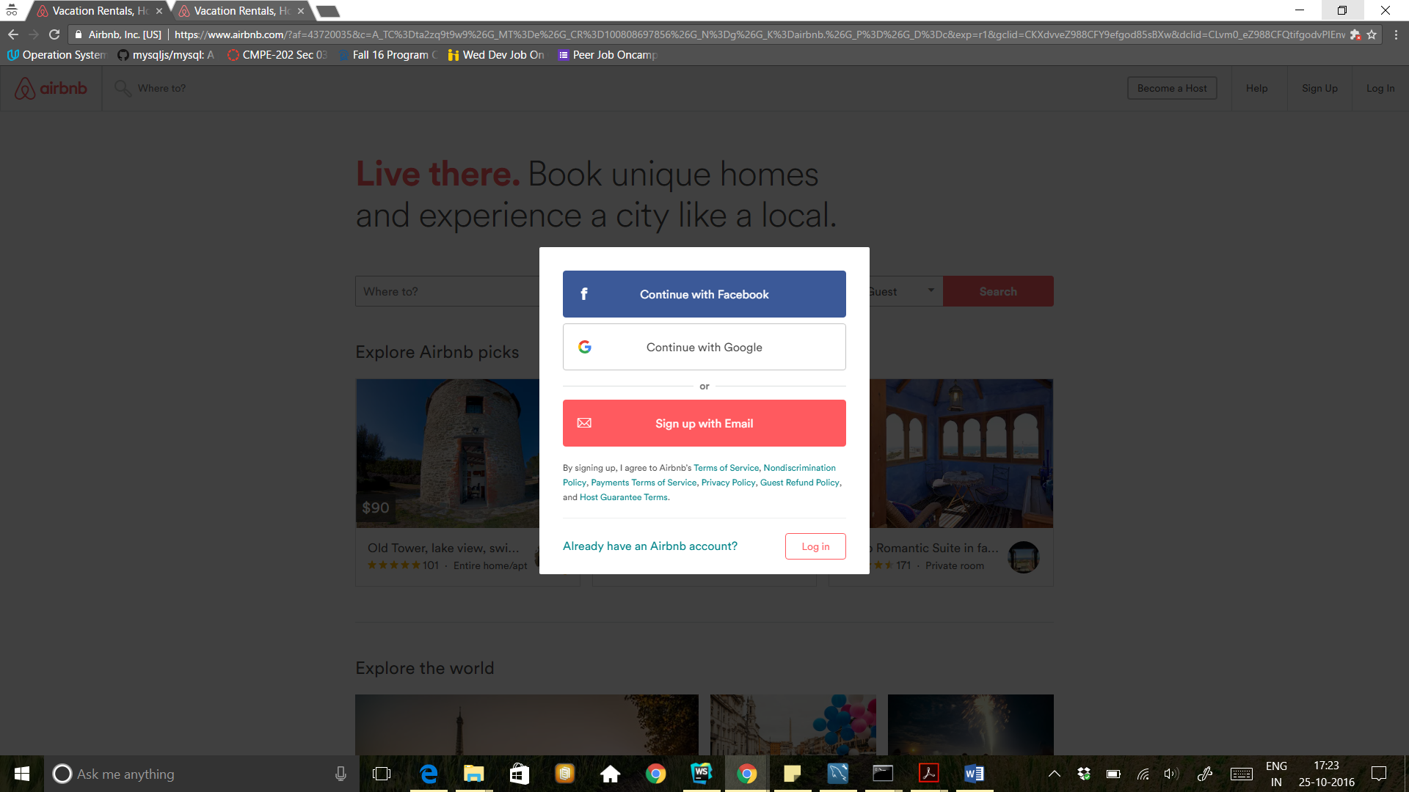

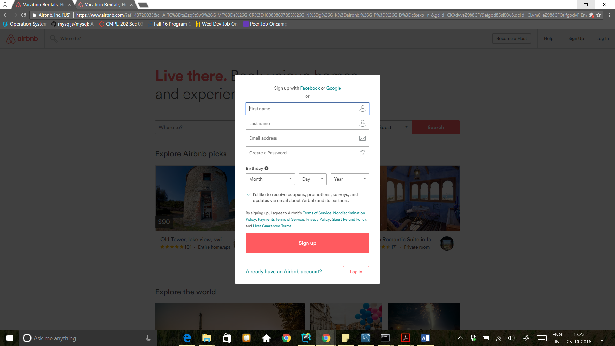

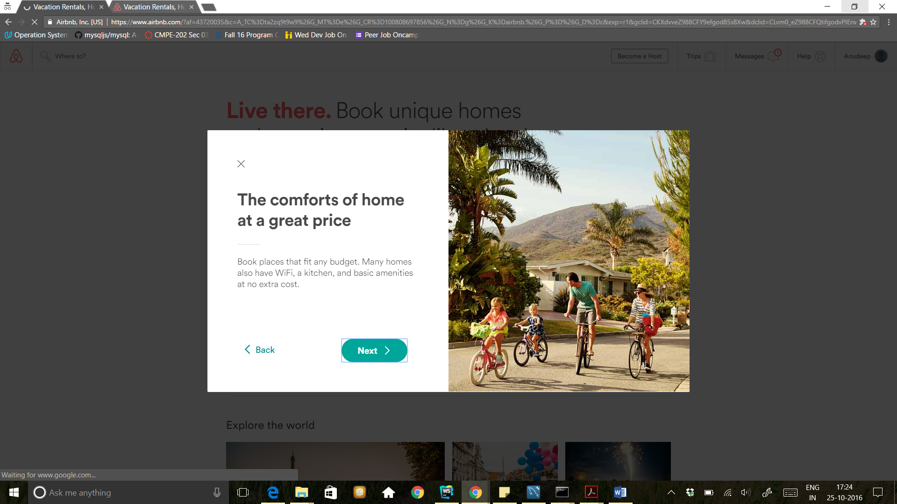

Delete

Edit

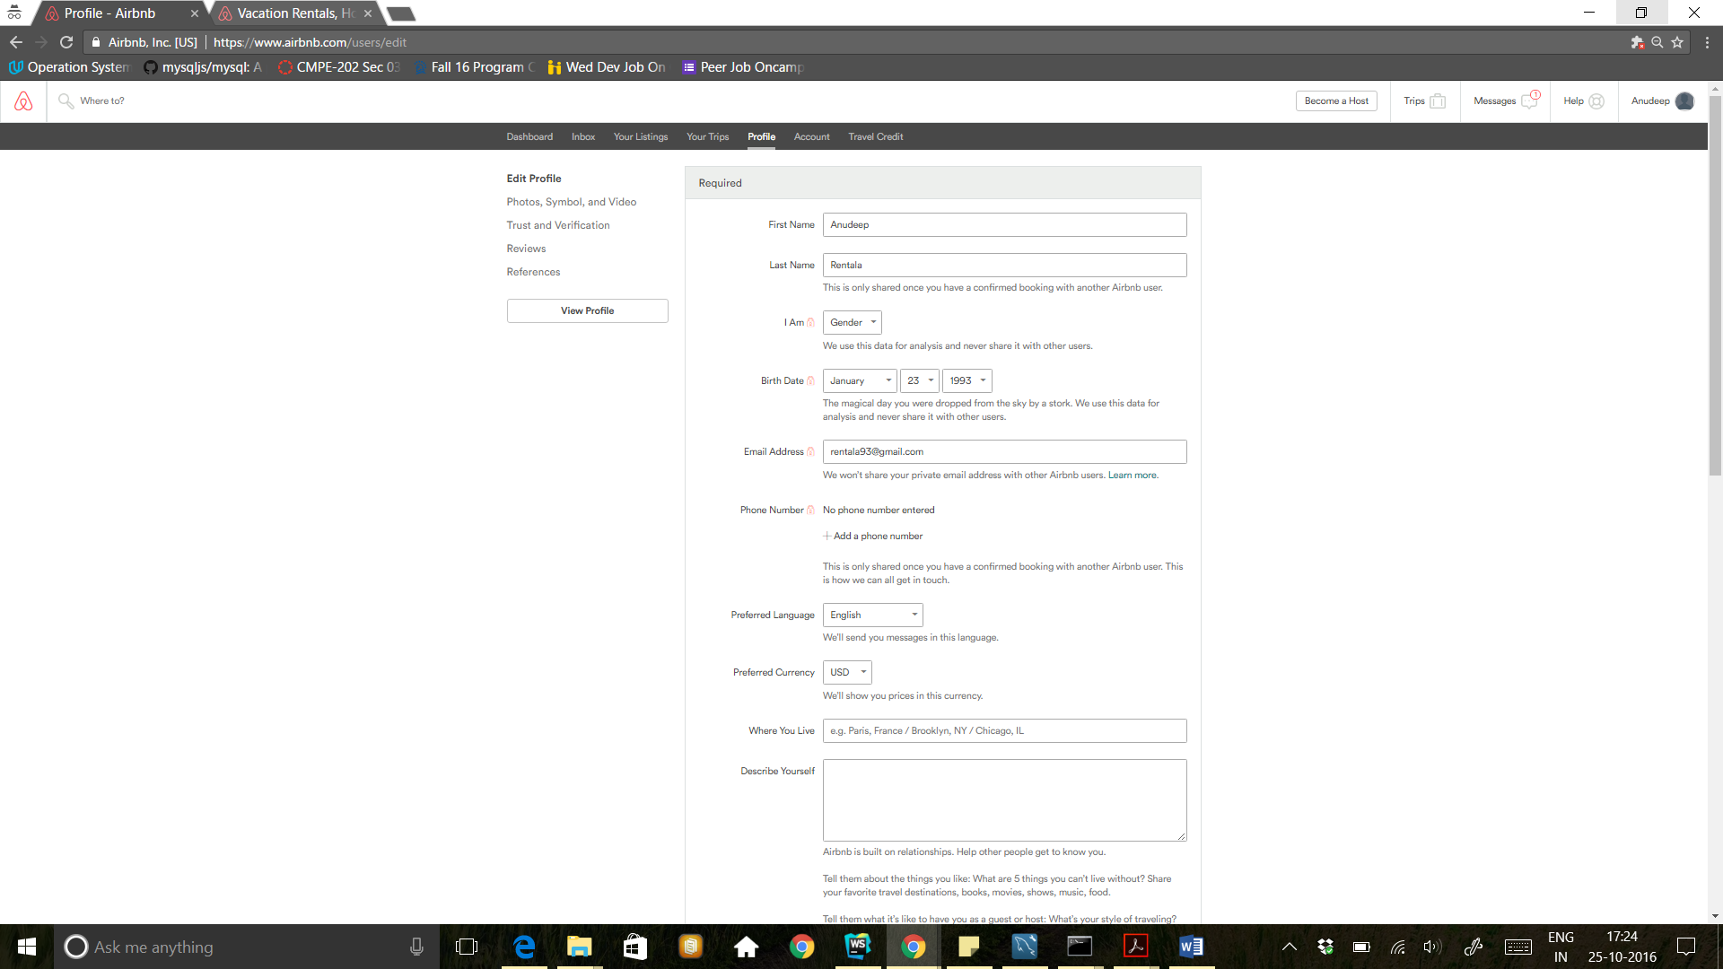

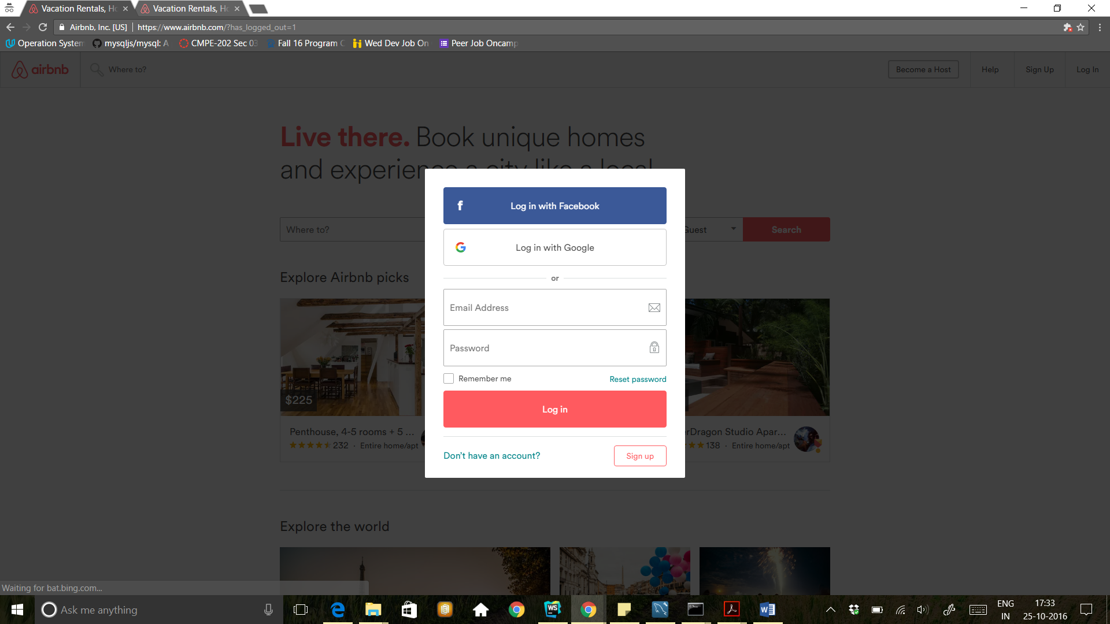

Host

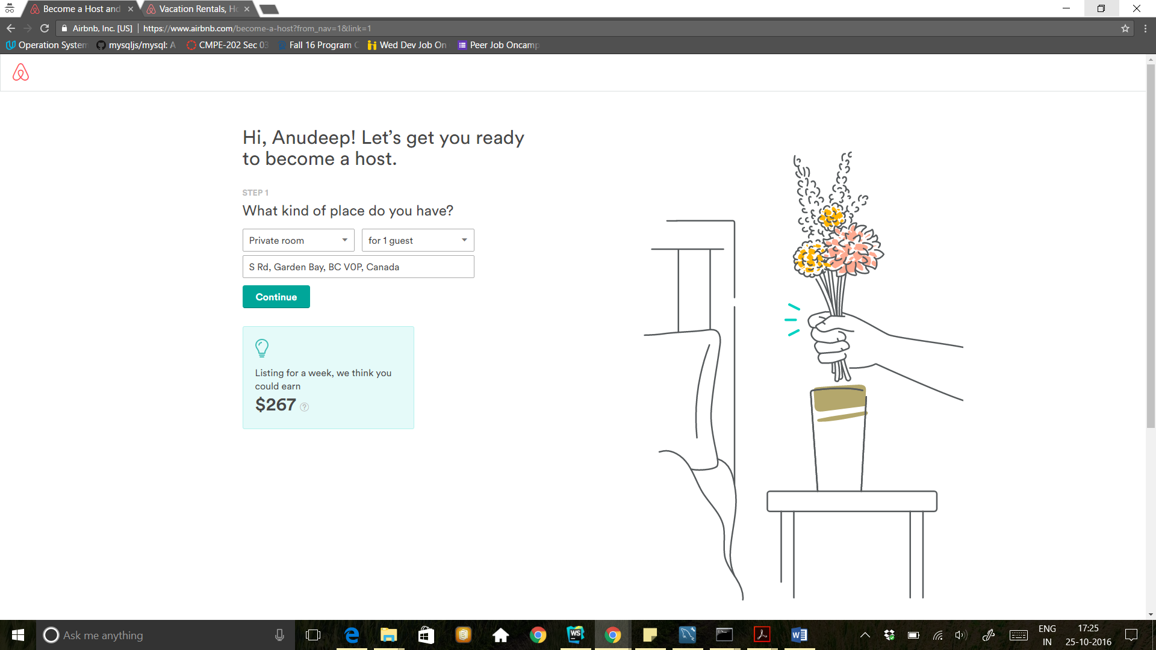

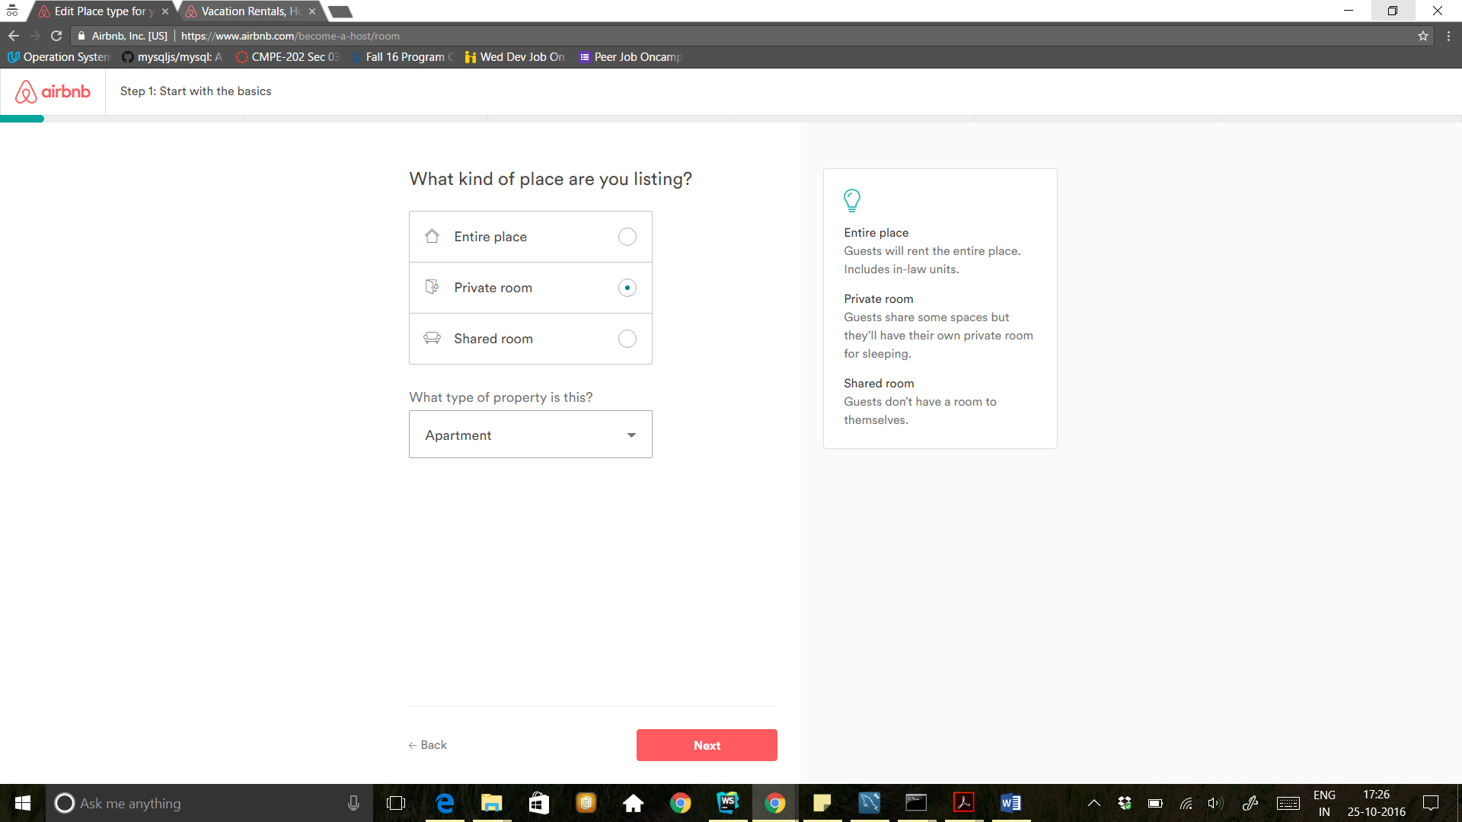

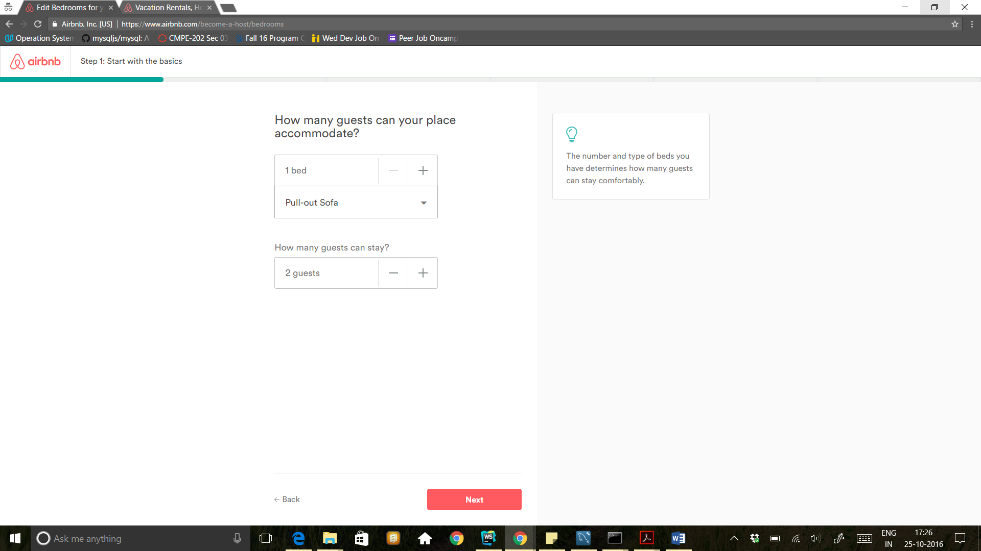

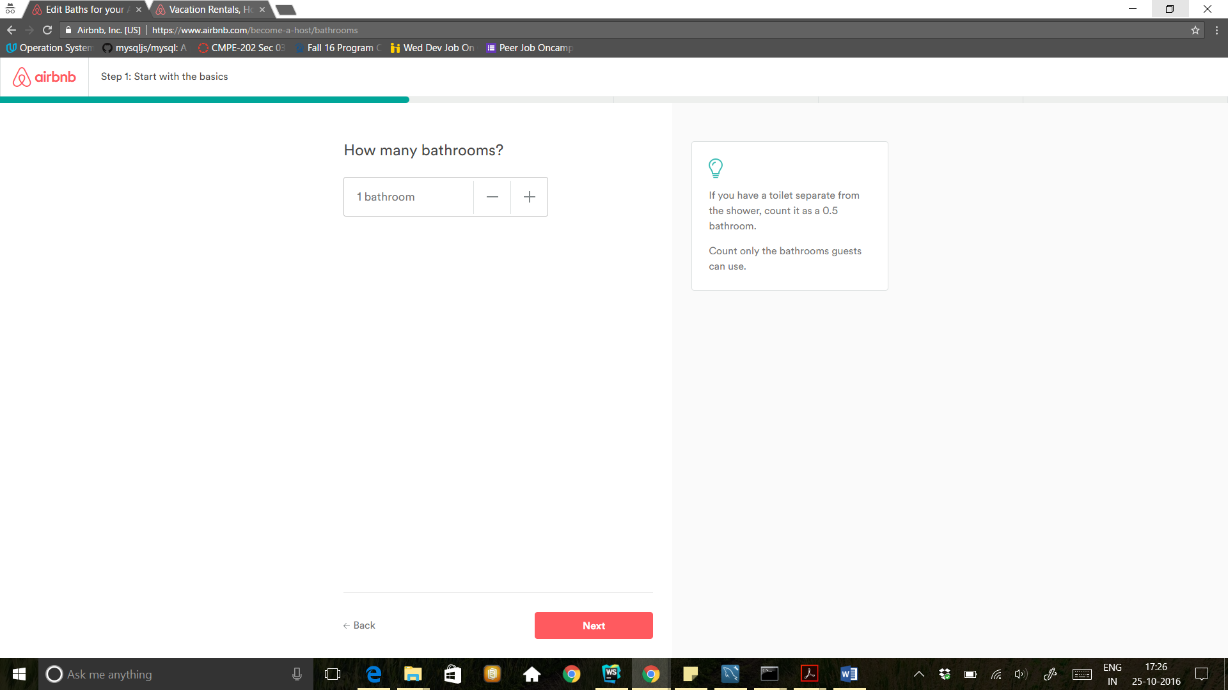

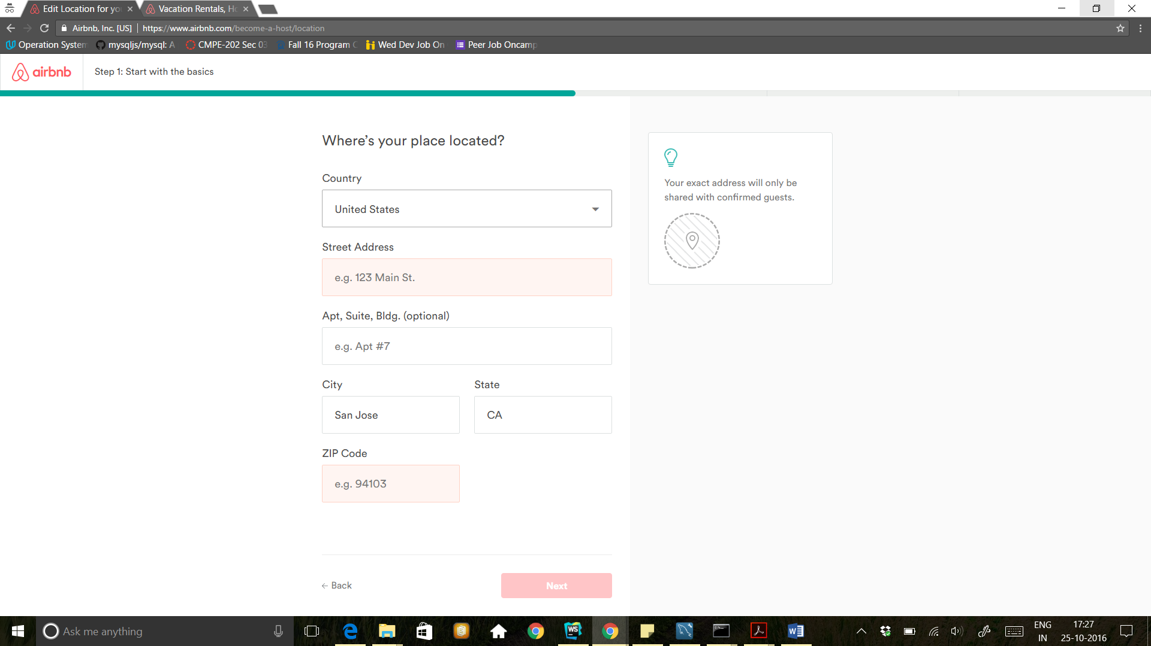

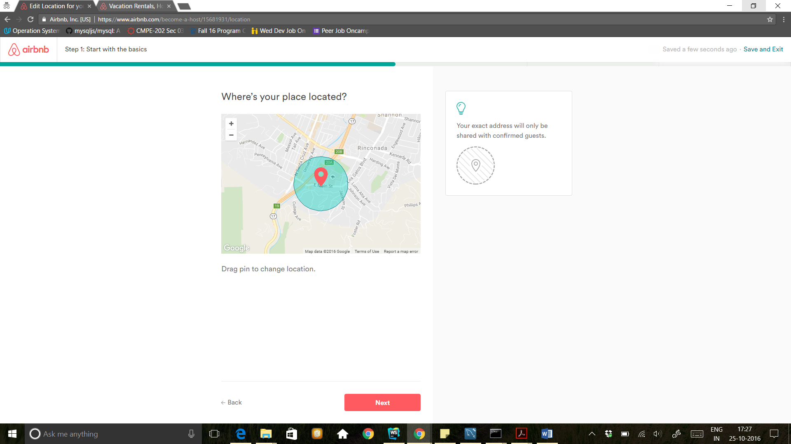

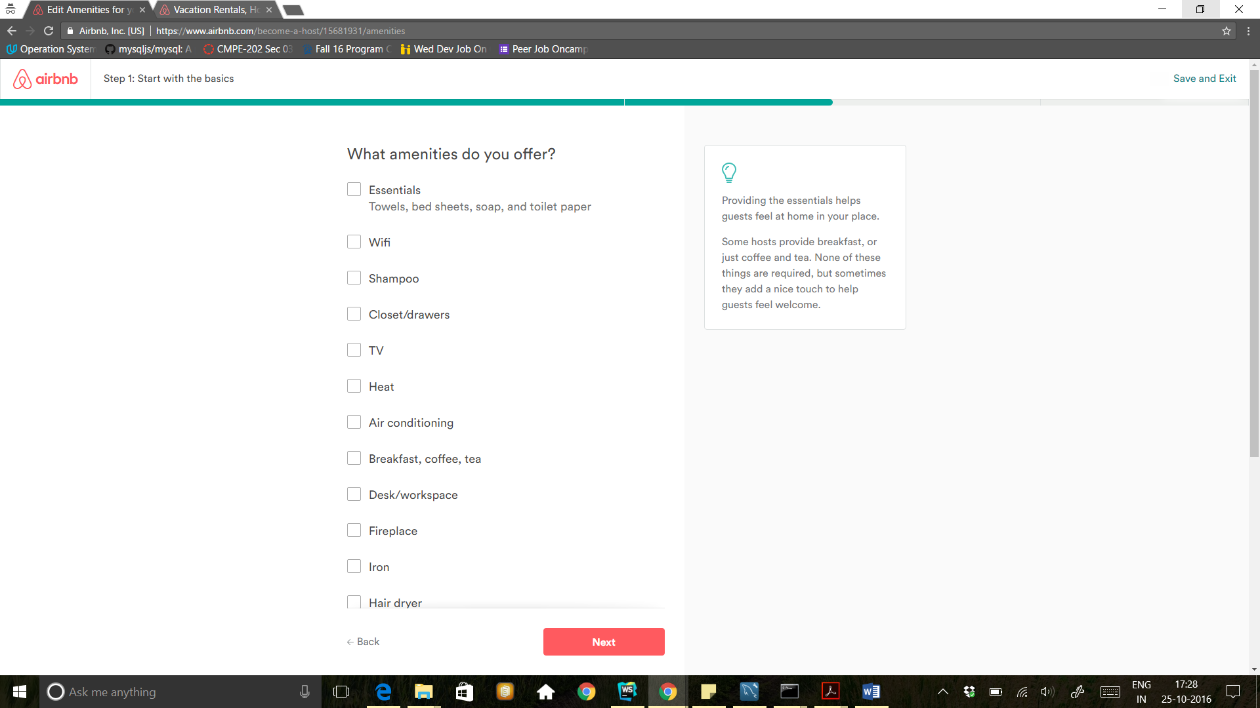

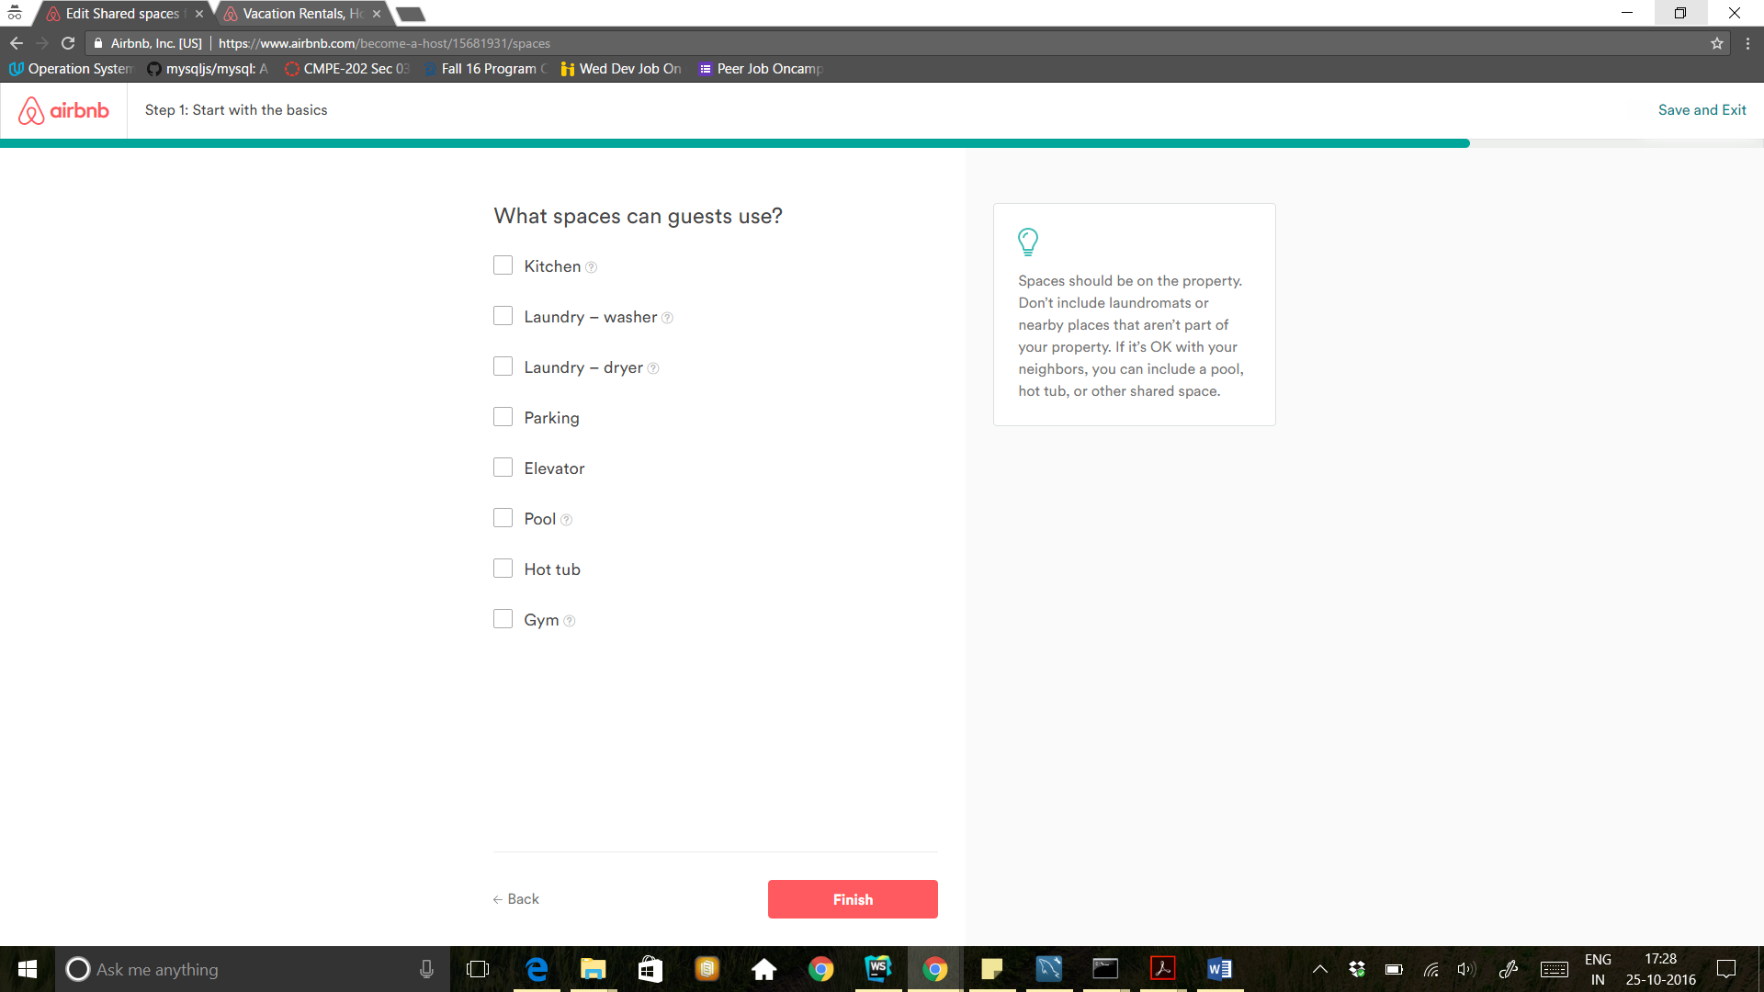

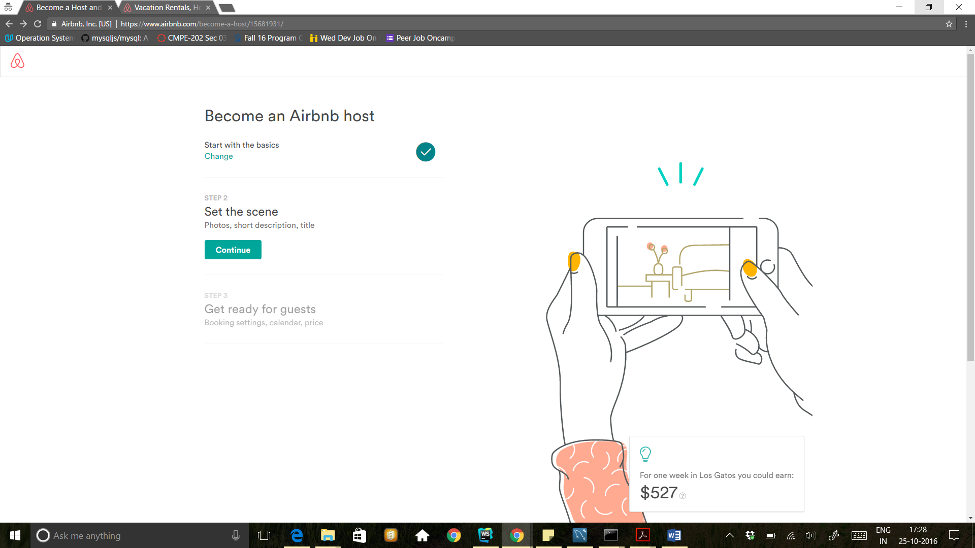

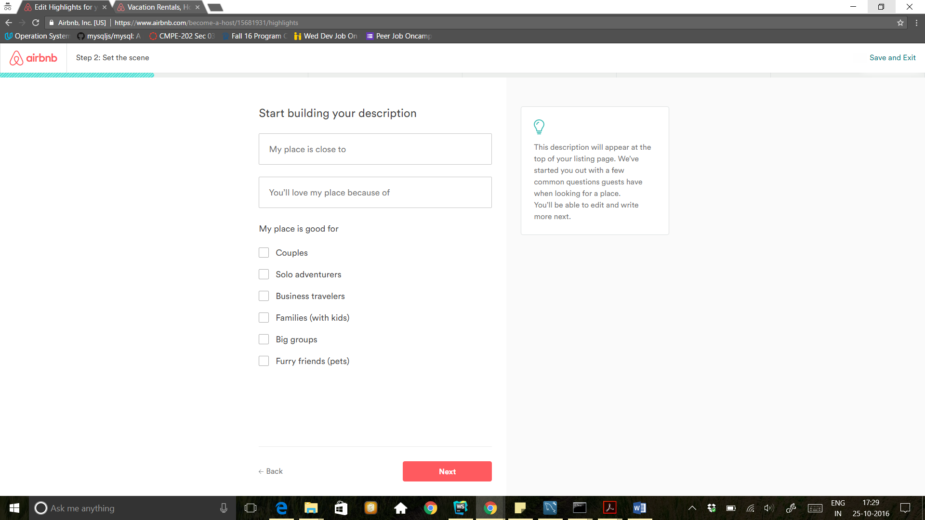

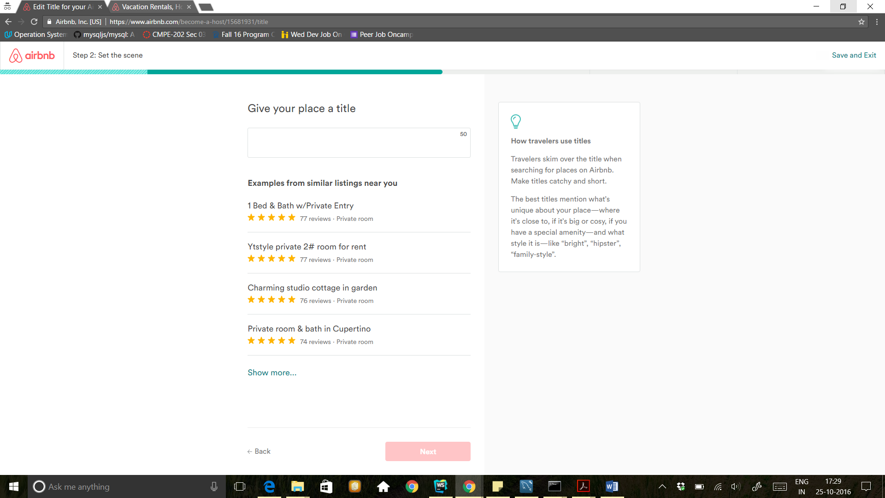

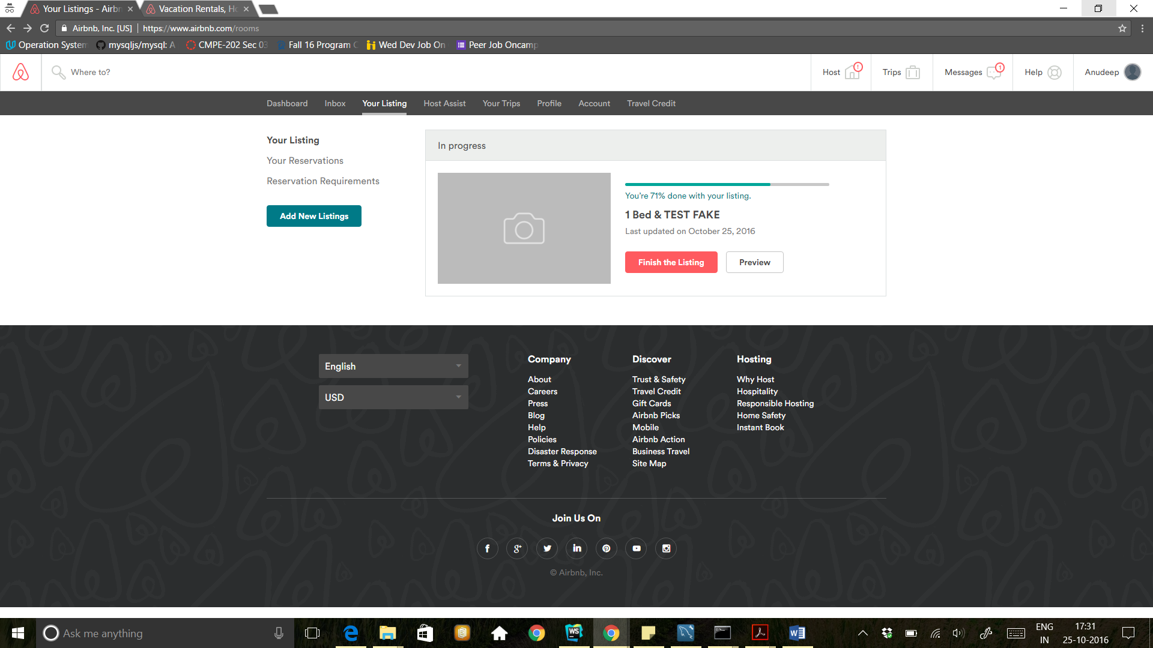

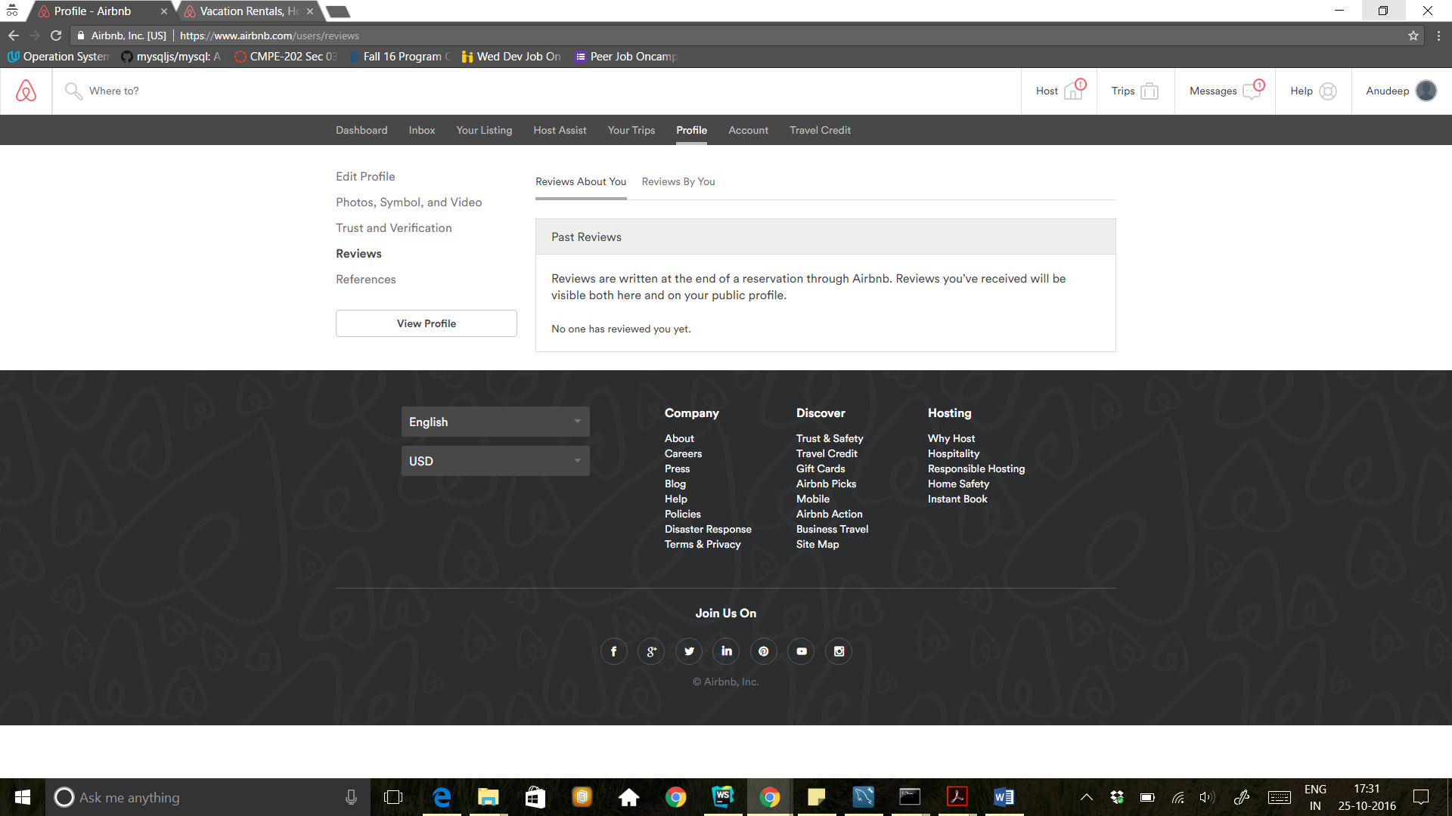

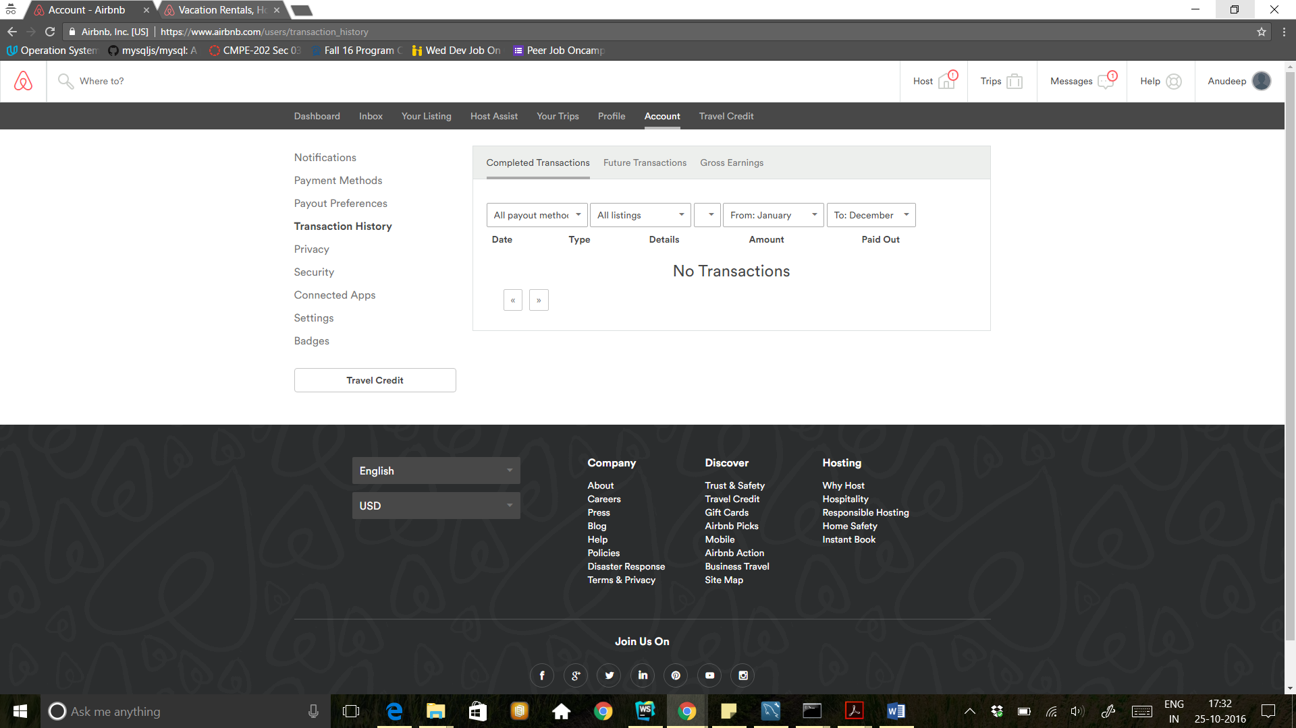

Billing Information

As seen in PDF

Administrator

Trips

Properties

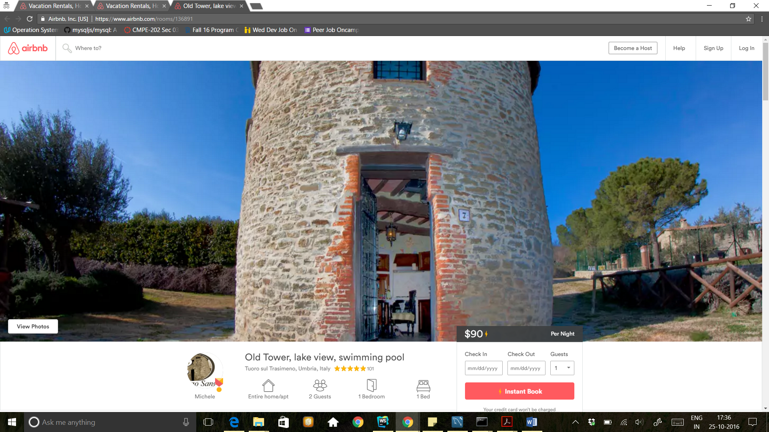

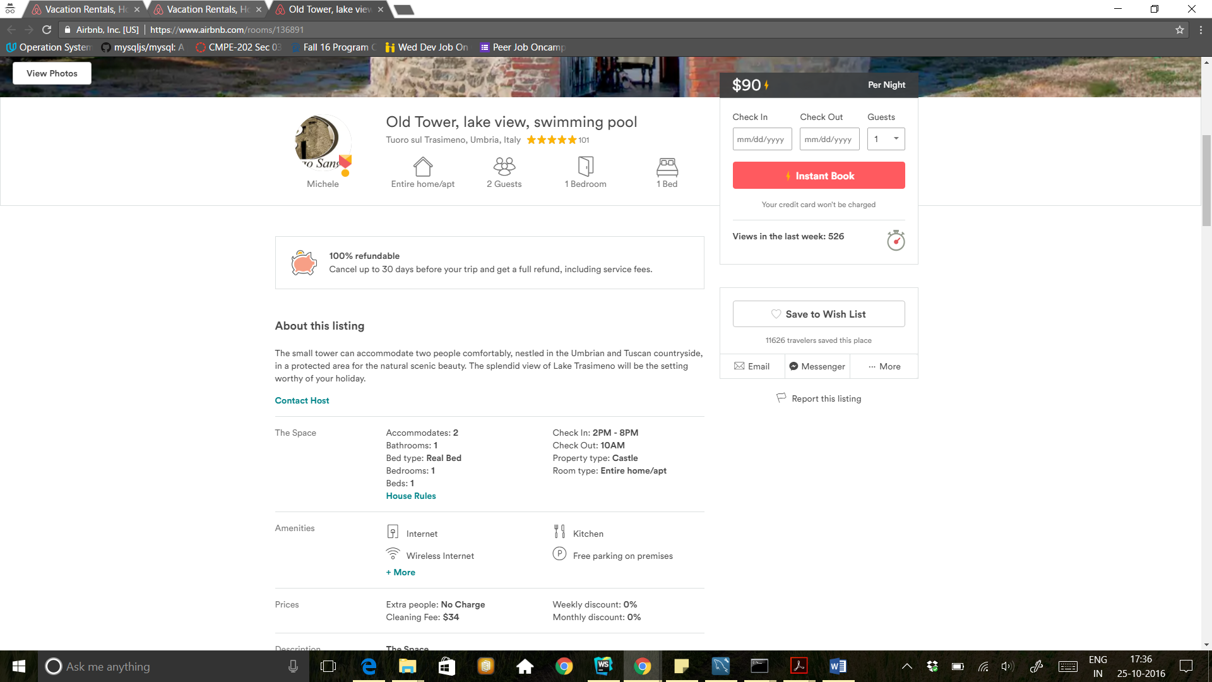

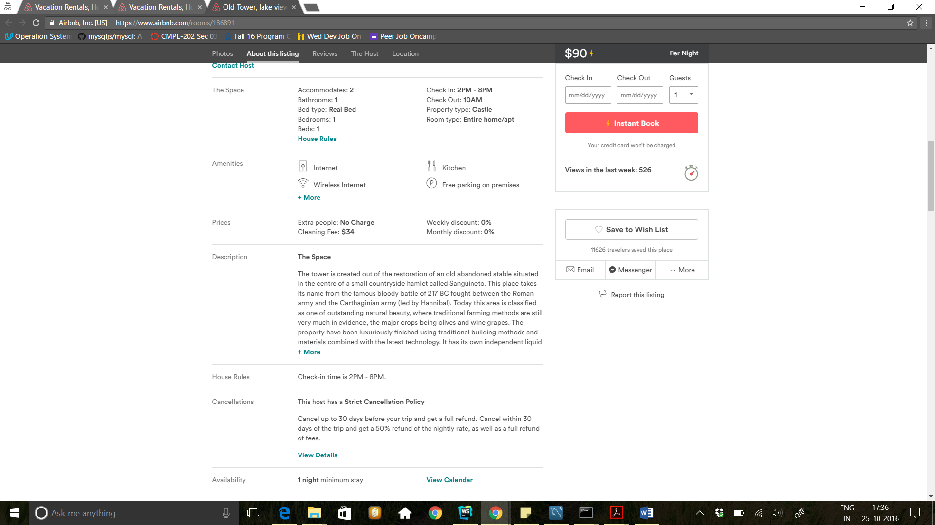

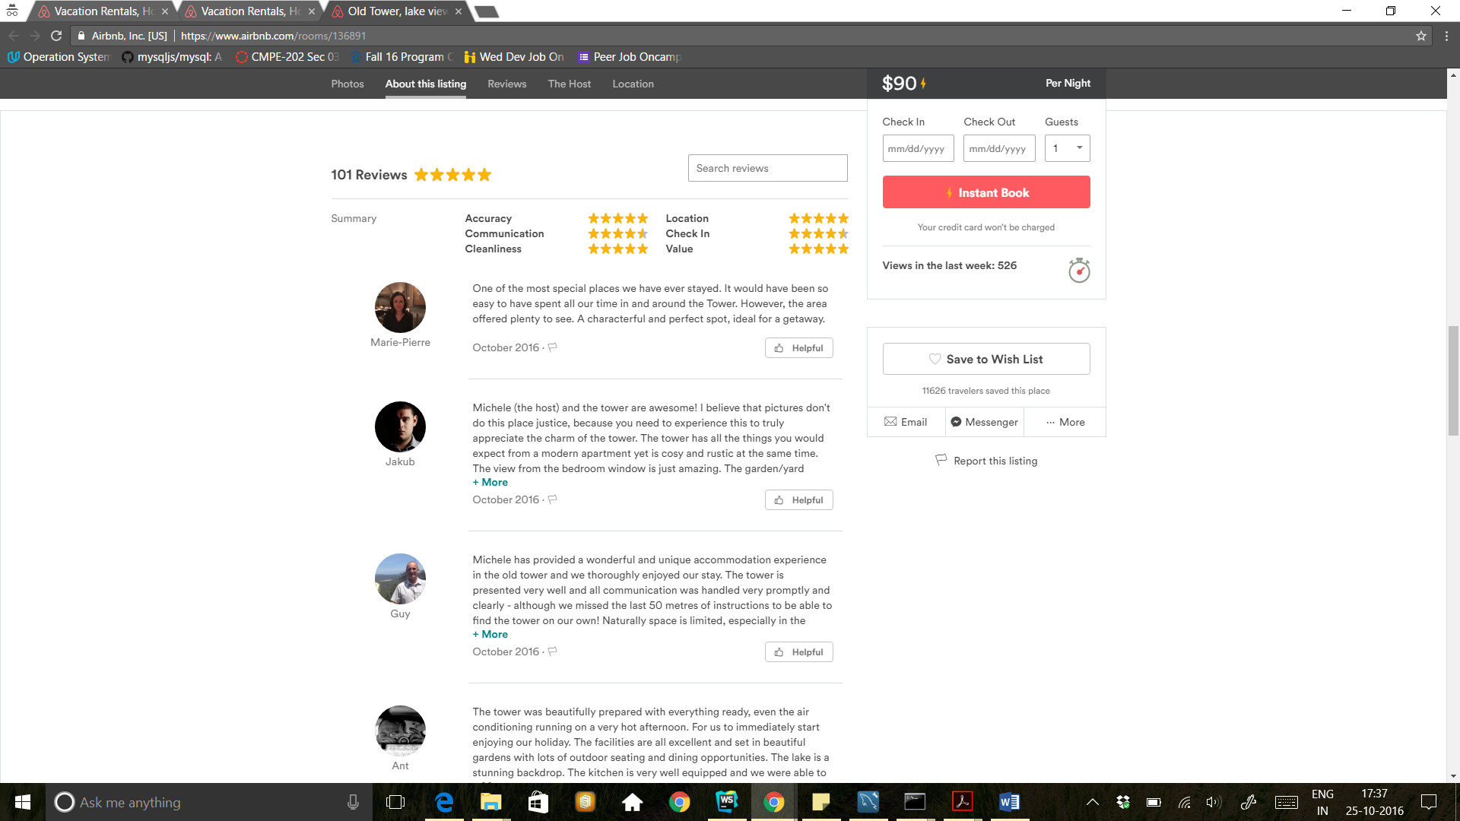

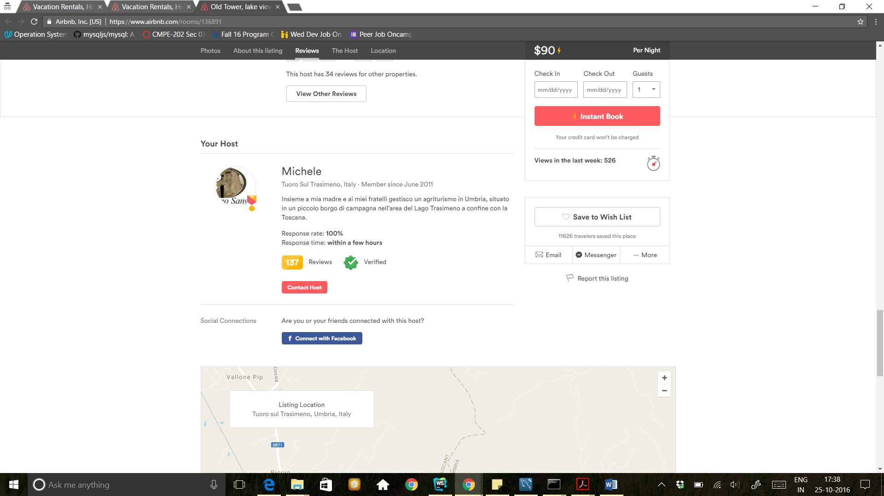

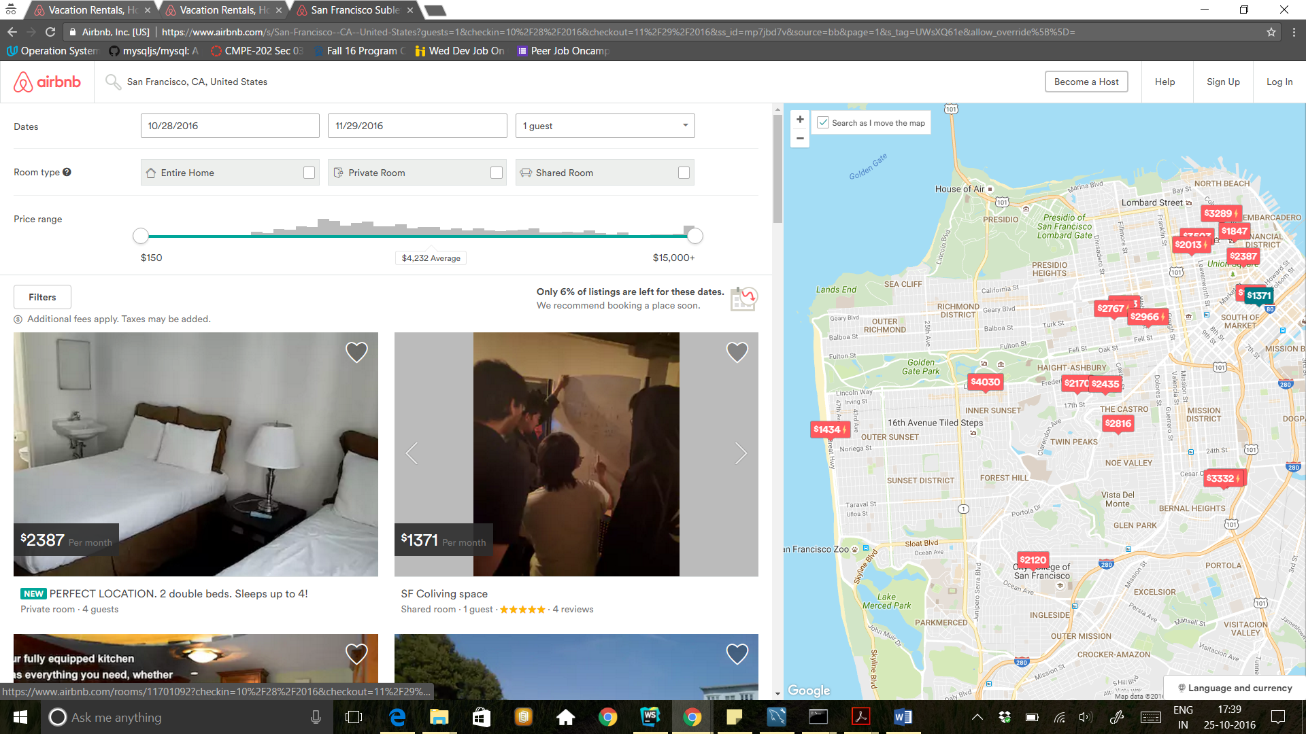

* **User Module/Service:**

· Create a new User (Reference AirBnb websites for fields informaton)

· Delete an existing User

· User can place the bid

· Change a user’s information (name, address,profile image etc) – *This function must support the ability to change ALL attributes*

· Search for a property based on attributes. You do not have to consider attributes that are not listed above in properties table (Use category table if needed).

· Display information about a User.

· Reviews and rating. Must be able to upload photos for properties while reviewing.

* **Host Module/Service:**

· Create a new Host.

· Delete an existing Host

. Dashboard : Able to see analytics activities.

· Generate Bill for a User (Every Trip).

· Upload introductory video.

· Upload images about events during his ride.

. Approval of requested property by user. (Accept/Denied)

* **Billing Module/Service:**

· Create a new Bill for each trip.

· Delete an existing Bill.

· Search an existing Bill.

* **Admin Module/Service:**

· Add host to the system.

. Search for enrolled host area wise. On clicking host, Host profile should get open

· Review host/customer account

· Search for a Bill based on attributes (fetch all bills By date, By months)

· Display information about a Bill.

* **Trips Module/Service:**

· Create a new trip.

· Edit an existing trip.

· Delete an existing trip.

· History of trips (Display in user’s account)

· History of trips (Display in host’s account)